Go Back To Where You Came From

This unit of work can be confronting!
As a student you will be working through this booklet and watching the TV series “Go Back To Where You Came From”. This TV series is based on 6 Australians who some admit they are racist or harsh towards immigrants especially “boat people”, this series takes these Australians on the journey of an illegal immigrant.
Activity One: Mindmap

What is an illegal
immigrant?

Activity Two: Mindmap

What countries do you think refugees and asylum seekers come from?

Activity Three: Mindmap

Why do you think refugees and asylum seekers leave their home countries?

Activity Four: After watching Episode 1
- How many Australians are there on this journey?
_________________________________________________________________

- What adventure are these Australians going on?
______________________________________________________________________________________________________________________________________________________________________________________________________

- Why do you think these Australians volunteered for this project?
______________________________________________________________________________________________________________________________________________________________________________________________________

- Would you volunteer to be a part of this project? Why or why not?
______________________________________________________________________________________________________________________________________________________________________________________________________

- How do you think you cope as a refugee?
______________________________________________________________________________________________________________________________________________________________________________________________________

- Do you agree with any of the participant’s views? Why or why not?
______________________________________________________________________________________________________________________________________________________________________________________________________
__________________________________________________________________
- What has shocked you so far?
________________________________________________________________________________________________________________________________________________________________________________________________________________________________________________________________________
- Is there anything you’d like to know more about, after watching this episode?
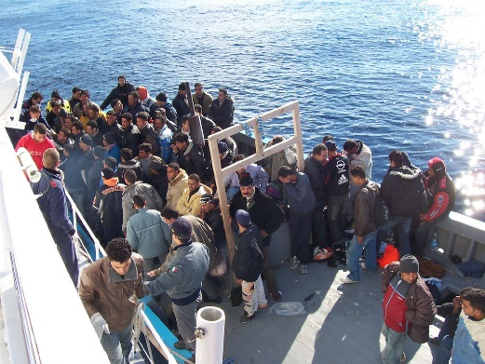
_____________________________________________
_____________________________________________
_____________________________________________
_____________________________________________
_____________________________________________
"Boat People at Sicily in the Mediterranean Sea" by Vito Manzari from Martina Franca (TA), Italy - Immigrati Lampedusa. Licensed under CC BY 2.0 via Commons

Activity Five: Sharing
Note: Sharing opinions about controversial topics can be complex. Be respectful when listening to the opinions of others, and clarify your reasons when sharing your own opinions.
